**Drafted content for newsletters week of January 6, 2025**

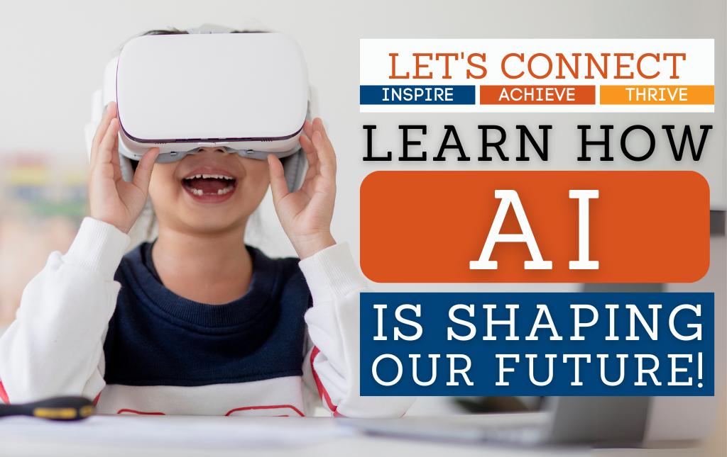

**Explore the future of education at our AI Let’s Connect event!**

**How is AI changing education?**

We invite parents, guardians, and students to come together for an exciting and interactive event to learn about artificial intelligence and how it is shaping education. This session will highlight how AI is transforming learning experiences, its ethical implications, and how it can be used responsibly in classrooms. Hear from district leaders and outside experts as they share insights and answer your questions.

**When:** Thursday, January 16  
**Time:** 6:30 - 7:30 p.m.  
**Where:** Eisenhower Middle School

**What is Let’s Connect?**  
Let’s Connect events are all about bringing our families and community members together for meaningful conversations on key topics like education technology, student well-being, and curriculum advancements.

We can’t wait to see you at the event as we explore how technology is transforming the way we teach and learn!